Personal Details (ОБРАЗЕЦ) |  |  |  |  |  |  | 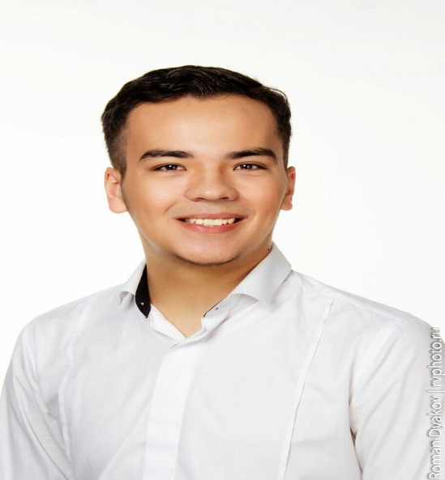
Name Surname |  | ILYA PARFENOV
Place of Birth |  | KAZAKHSTAN |  | Date of Birth | 12.02.1997
Height |  | 178 |  | Weight | 80
E-Mail |  | Ilya_parfenov_97@mail.ru |  | Skype | la.no4ka22
Tel |  | +7913-739-01-10 |  | Facebook/  Insta Name | -
International Passport No |  | 69711589 |  | Whatsapp | 7-913-739-01-10
When Can You Start  To Work? |  | 01.04.2021 |  | Applied Position | guide
Education
Dates |  | School / University |  |  |  | Subject |  |  | Country
09.2015-06.2020 |  | Novosibirsk State Technical University |  |  |  | management |  |  | Russia
Received Certificates (УКАЖИТЕ ЕСЛИ ИМЕЮТСЯ – СЕРТИФИКАТЫ)
Dates |  | Association |  |  |  | Profession |  |  | Country
- |  | - |  |  |  | - |  |  | -
Experience
Start/Finish |  | Brand of Employer |  |  |  | Country |  | Position
11.2018-04.2019 |  | Black star burger |  |  |  | Russia |  | waiter
Languages - (1 Bad - 5 Very Good) |  |  |  |  |  |  | Computer Knowledge
Language | Speaking |  | Reading |  | Writing |  | Computer Skills
English | 3 |  | 3 |  | 3 |  | Word/Excel |  | Yes | No
Russian | 5 |  | 5 |  | 5 |  | Fidelio |  | Yes | No
Other |  |  |  |  |  |  | Micros |  | Yes | No
 |  |  |  |  |  |  | Sedna |  | Yes | No
Explain About Your Self
Do you have any health problems? No

Have you ever been convicted of crime? No

Why do you want to work as a guide? In what ways is your personality suitable for this job? Give examples;
Once I visited Thailand, then I started to work in this field, long went to this dream, and enrolled in tourism. I like to study the traditions and cultures of different countries, I can find a common language with people, I like when people are interested, and I want to expand my experience and knowledge, I want to connect my life with tourism.

Have you ever been abroad for any purpose? Where and why did you go? How long did you stay?
I visited three countries, this is Thailand, Turkey, Tashkent. The purpose of all these visits was to travel and rest. The duration was from seven days to fifteen days.

IMPORTANT
Please;
Write clearly by handwriting in ink, and use BLOCK CAPITALS
Read and answer all the questions carefully
Tick the boxes for short answers
Attach your current photograph on the specific area (Forms without photograph will not be accepted)
Ensure you have signed and dated the form in the following box
Any misrepresentation of facts or material omission there of shall be cause for dismissal

НИЖЕ ФОТО В РОСТ НА РОВНОМ ФОНЕ

